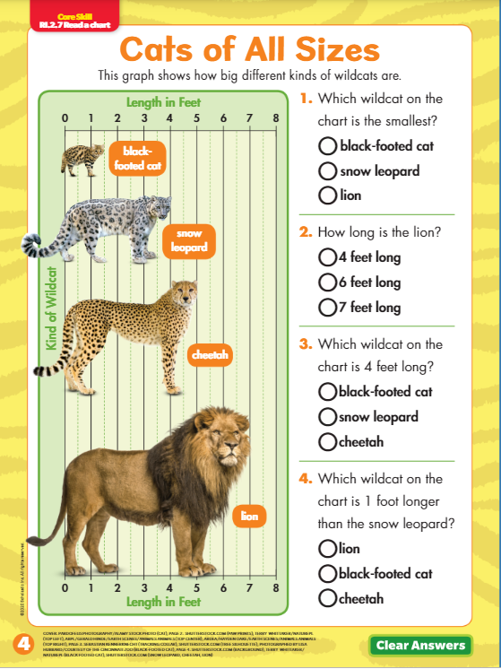

Extension Questions:

Why is the black-footed cat endangered?

Why is the black-footed cat considered the most dangerous cat?

